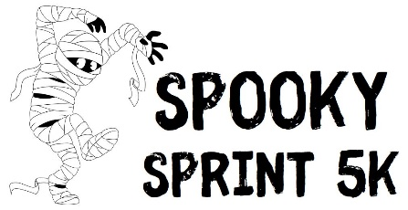
2023 Sponsorship Form
Thank you for your interest in sponsoring the Northview Education Foundation’s 5K Spooky Sprint. Please see the below sponsorship opportunities. We thank you in advance for your generous contribution which is tax deductible.

___ Yes, I want to be a proud sponsor of the 2023 NEF 5K Spooky Sprint
Business Name: |  |  | Contact:
Phone: |  | Email:
 | Presenting Sponsor $550
- Business logo on t-shirts
- Goody bag insert (provided by sponsor) disperse business materials or coupons in event goodie bag
- (4) 5K race entries

 | Gold Sponsor $350
- Business logo on t-shirts
- Goody bag insert (provided by sponsor) disperse business materials or coupons in event goodie bag
- (2) 5K race entries

 | Contributing Sponsor $150
- Goody bag insert (provided by sponsor) disperse business materials or coupons in event goodie bag
- (1) 5K race entry

PLEASE EMAIL CAMERA-READY LOGO TO NEF@NVPS.NET
MONIES DUE BY OCTOBER 10, 2023
Please address payments to: Northview Education Foundation
ATTN: NEF -5K Race, 4365 Hunsberger NE, Grand Rapids, MI 49525

